# Hapag-Lloyd

German international shipping company

**Hapag-Lloyd AG** is a German international shipping and container [transportation company](https://en.wikipedia.org/wiki/Transportation_company" \o "Transportation company), the 4th biggest in the world. It was formed in 1970 through a merger of [Hamburg-American Line](https://en.wikipedia.org/wiki/Hamburg-American_Line) (HAPAG) and [Norddeutscher Lloyd](https://en.wikipedia.org/wiki/Norddeutscher_Lloyd" \o "Norddeutscher Lloyd).

[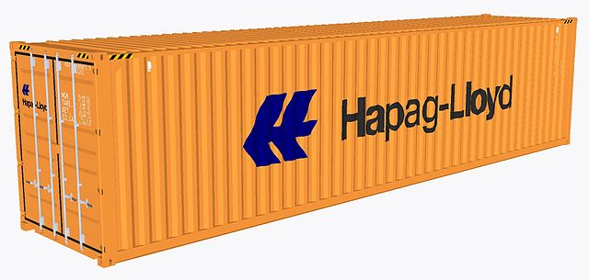](https://en.wikipedia.org/wiki/File:Hapag-Lloyd_shipping_container.jpeg)

Hapag-Lloyd 40ft container

[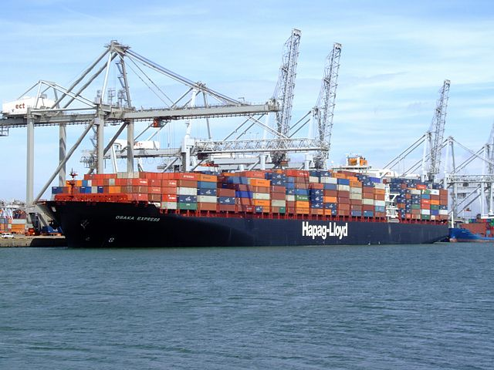](https://en.wikipedia.org/wiki/File:Osaka_Express,_at_the_Amazone_harbour,_Port_of_Rotterdam,_Holland_14-Jul-2007.jpg)

*Osaka Express* at Port of Rotterdam

Hapag and NDL continued to compete until they established a joint-venture container line. The "Hapag-Lloyd Container Line", founded in 1967 and operating from 1968 onward, was established to share the huge investments related to the containerisation of the fleets. The two companies finally merged on September 1, 1970, under the name *Hapag-Lloyd*.

Hapag-Lloyd was acquired in 1998 by Preussag AG (since 2002 named [TUI AG](https://en.wikipedia.org/wiki/TUI_AG) ([Hanover](https://en.wikipedia.org/wiki/Hanover" \o "Hanover))), a tourism conglomerate, and became its fully-owned subsidiary in 2002.

In August 2008, TUI announced an intention to sell its entire stake in Hapag-Lloyd shipping activities before the end of that year. Industry speculation predicted a sale price of approximately $US5.9 billion.

In October 2019, Hapag-Lloyd acquired a 10 percent stake in Container Terminal 3 (TC3) of the Tangier Med 2 port in Morocco.

In April 2022, Hapag-Lloyd acquired a participation in JadeWeserPort Wilhelmshaven, taking ownership of a 30 percent stake in Container Terminal Wilhellmshaven (CTW) and a 50 percent stake in Rail Terminal Wilhelmshaven (RTW).

In August 2023, it was announced Hapag-Lloyd had acquired SM SAAM's terminal business and related logistics services in the [Americas](https://en.wikipedia.org/wiki/Americas" \o "Americas).

On January 12, 2023, Hapag-Lloyd acquired a 49% minority stake in Spinelli Group, an Italian terminal and transport operator. Around three months later, on April 19, 2023, Hapag-Lloyd also acquired a 40% stake in J M Baxi Ports & Logistics Limited (JMBPL), a terminal and inland transport service provider in India.

shareholders of UASC would become the largest shareholder in the new entity, whilst Hapag-Lloyd would absorb all operations and assets of UASC.

[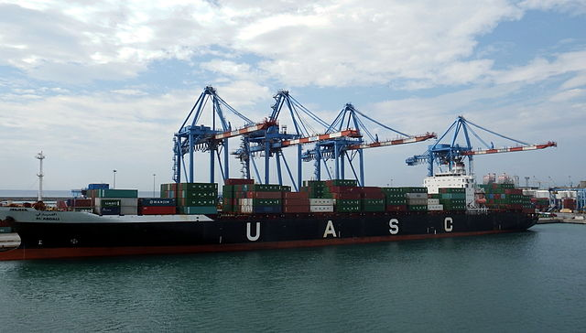](https://en.wikipedia.org/wiki/File:UASC_Al_Abdali_berthed_at_SECH_(Genoa).JPG)

UASC's *Al Abdali*

Historically United Arab Shipping Company was jointly established in July 1976 by the six shareholding governments of the Arab states of the Gulf ([Bahrain](https://en.wikipedia.org/wiki/Bahrain" \o "Bahrain), [Iraq](https://en.wikipedia.org/wiki/Iraq" \o "Iraq), [Kuwait](https://en.wikipedia.org/wiki/Kuwait" \o "Kuwait), [Qatar](https://en.wikipedia.org/wiki/Qatar" \o "Qatar), [Saudi Arabia](https://en.wikipedia.org/wiki/Saudi_Arabia" \o "Saudi Arabia) and [UAE](https://en.wikipedia.org/wiki/UAE)). Originally based in Kuwait, its corporate headquarters then moved to Dubai during the Iraqi conflict, and only some departments were moved back after the war.

The UASC fleet operated more than 45 services, connecting the [Middle East](https://en.wikipedia.org/wiki/Middle_East" \o "Middle East) to [Europe](https://en.wikipedia.org/wiki/Europe), the Mediterranean, Indian Sub-continent, [Far East](https://en.wikipedia.org/wiki/Far_East), [West Africa](https://en.wikipedia.org/wiki/West_Africa) and the Americas. Its network covered over 220 ports, offering containerized and conventional cargo shipping by a fleet of 58 owned and chartered vessels. On June 29, 2016, UASC's six shareholding states voted unanimously to approve the proposed merger. The deal gave a relative valuation of the two businesses at 72 percent for Hapag-Lloyd and 28 percent for UASC. At the time of the merger, UASC was 51 percent owned by Qatar and 35 percent owned by Saudi Arabia government, with the remainder held by other Arab states.

### NileDutch Transport & Shipping

In March 2021, Hapag-Lloyd announced the acquisition of Nile Dutch Investments B.V., a leading container service provider to and from West Africa. The transaction was effectively closed on July 8, 2021.

### Deutsche Afrika-Linien

On June 1, 2022, Hapag-Lloyd closed the acquisition of the container liner business of German carrier [Deutsche Afrika-Linien (DAL)](https://en.wikipedia.org/wiki/Deutsche_Afrika-Linien/John_T._Essberger_Group_of_Companies" \o "Deutsche Afrika-Linien/John T. Essberger Group of Companies), another Africa specialist, operating with liner services between Europe, South Africa and the Indian Ocean.